12020-Star Lion College Of Education,Ayyampet,
ADC Awareness Programme
By
Cycle Rally -13.01.2026
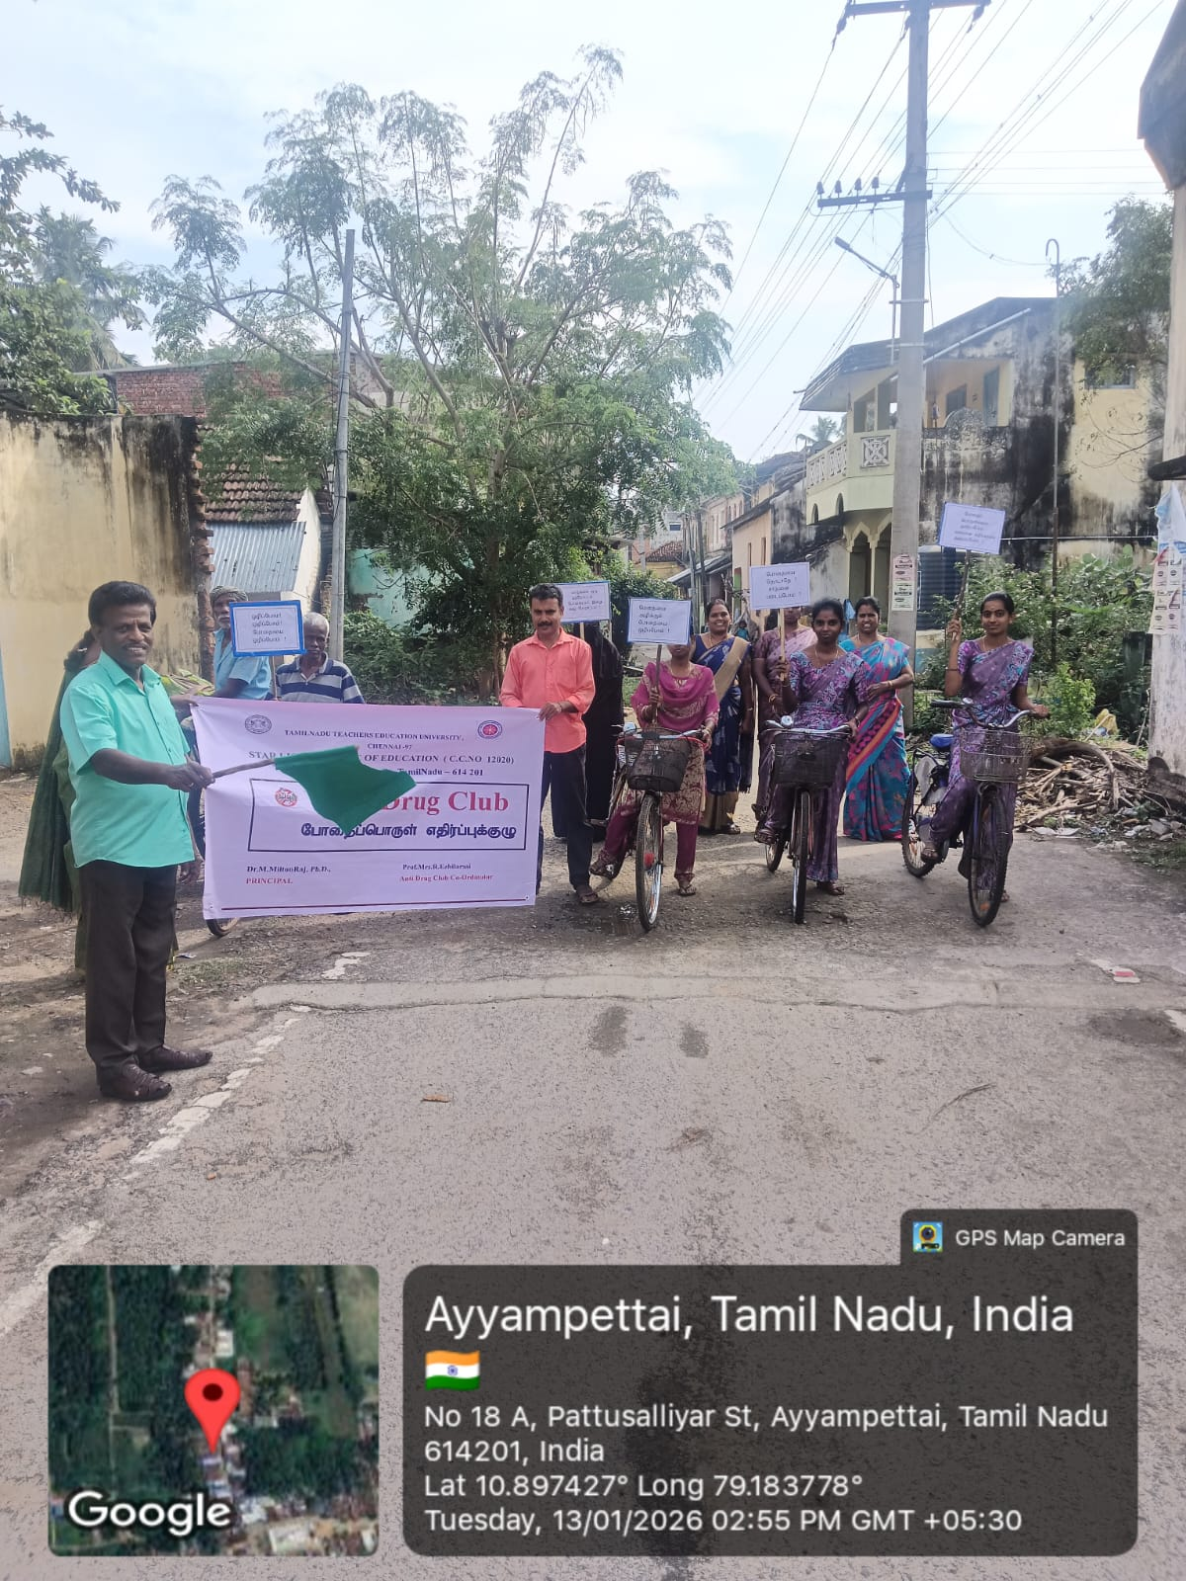
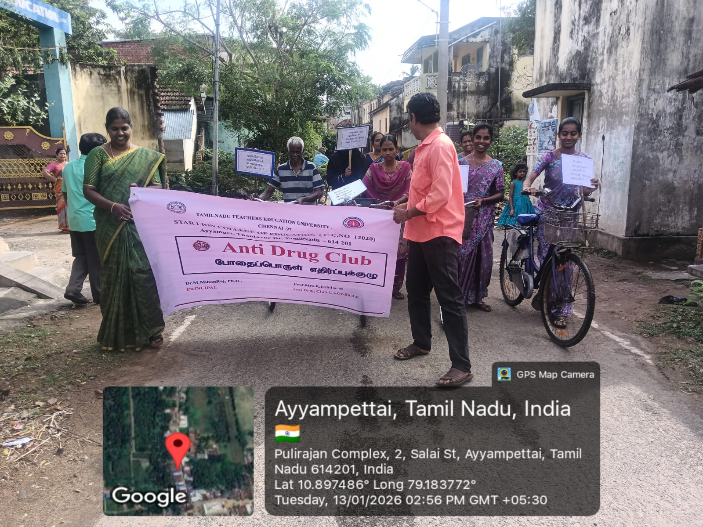
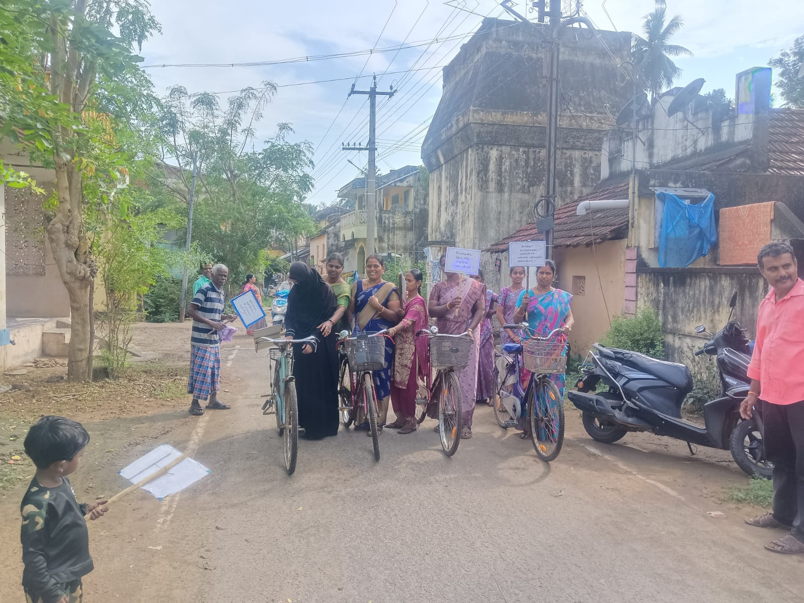
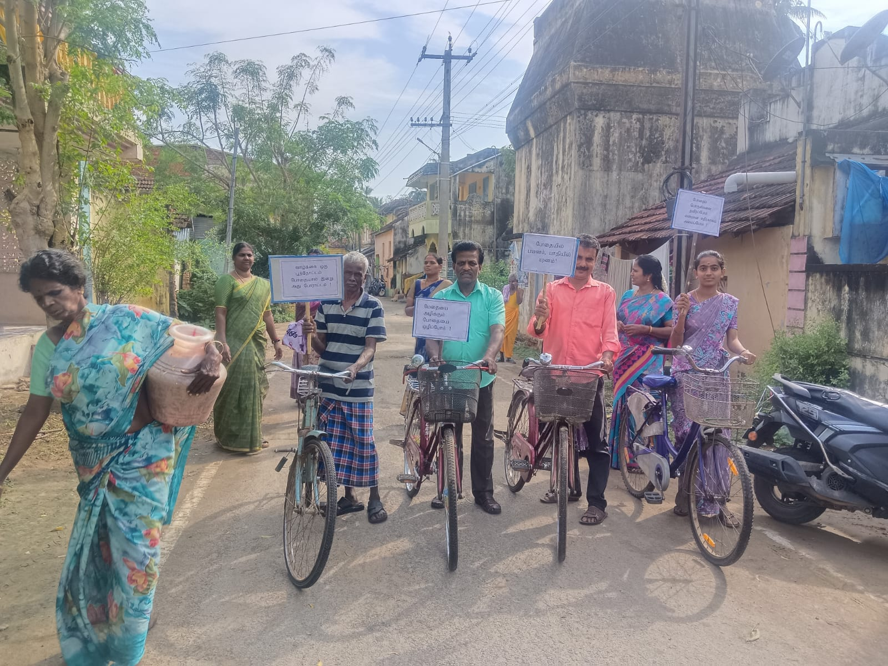
An Awarness programme against drugs abuse was conducted today at 2.30 P.M by the anti Drug Committe of Star Lion College Of Education Students are participated in the event , cycling through awareness programme the main street’s of Ayyampettai Professors and office staff members also took part in the programme .
**********

